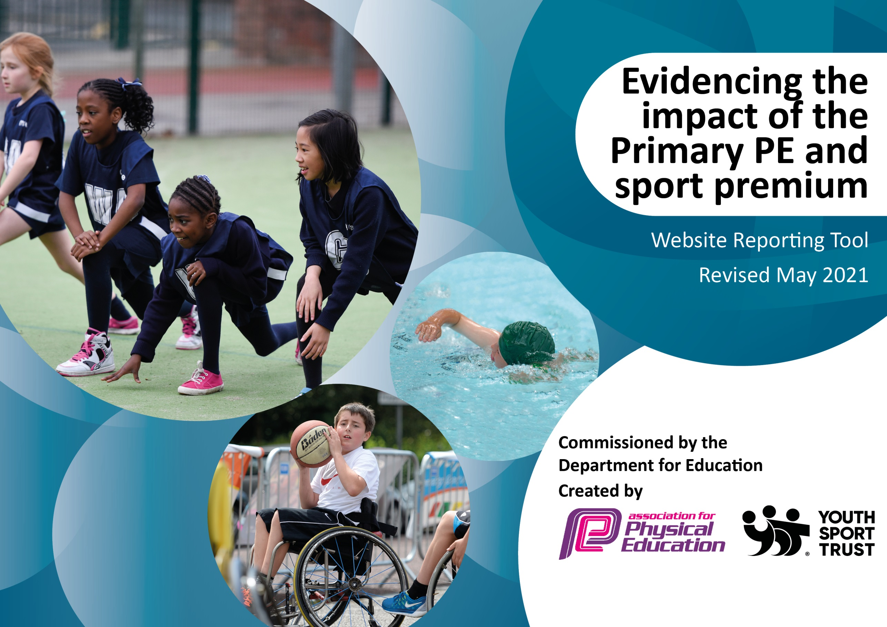

It is important that your grant is used effectively and based on school need. The Education Inspection Framework (Ofsted 2019 p64) makes clear there will be a focus on ‘whether leaders and those responsible for governors all understand their respective roles and perform these in a way that enhances the effectiveness of the school’.

Under the Quality of Education criteria (p41) inspectors consider the extent to which schools can articulate their curriculum (INTENT), construct their curriculum (IMPLEMENTATION) and demonstrate the outcomes which result (IMPACT).

To assist schools with common transferable language this template has been developed to utilise the same three headings which should make your plans easily transferable between working documents.

Schools must use the funding to make additional and sustainable improvements to the quality of Physical Education, School Sport and Physical Activity (PESSPA) they offer. This means that you should use the Primary PE and sport premium to:

- Develop or add to the PESSPA activities that your school already offer
- Build capacity and capability within the school to ensure that improvements made now will benefit pupils joining the school in future years
- The Primary PE and sport premium should not be used to fund capital spend projects; the school’s budget should fund these.
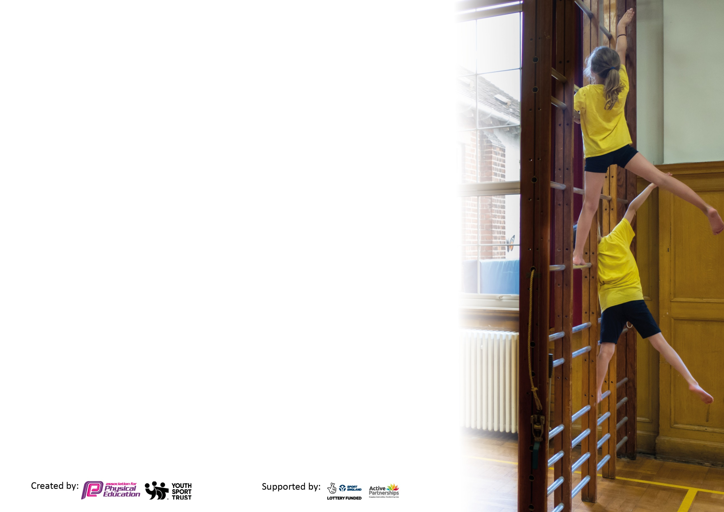
Please visit gov.uk for the revised DfE guidance including the 5 key indicators across which schools should demonstrate an improvement. This document will help you to review your provision and to report your spend. DfE encourages schools to use this template as an effective way of meeting the reporting requirements of the Primary PE and sport premium.

We recommend you start by reflecting on the impact of current provision and reviewing the previous spend.

Schools are required to publish details of how they spend this funding, including any under-spend from 2019/2020, as well as on the impact it has on pupils’ PE and sport participation and attainment by the end of the summer term or by 31st July 2021 at the latest.

We recommend regularly updating the table and publishing it on your website throughout the year. This evidences your ongoing self-evaluation of how you are using the funding to secure maximum, sustainable impact. Final copy must be posted on your website by the end of the academic year and no later than the 31st July 2021. To see an example of how to complete the table please click HERE.

Please note: Although there has been considerable disruption in 2020 it is important that you publish details on your website of how you spend the funding - this is a legal requirement.
Support for review and reflection - considering the 5 key indicators from DfE, what development needs are a priority for your setting and your pupils now and why? Use the space below to reflect on previous spend and key achievements and areas for development.

N.B. In this section you should refer to any adjustments you might have made due to Covid-19 and how these will influence further improvement.
Key achievements to date until July 2020: | Areas for further improvement and baseline evidence of need:
More inter- sports clubs. Up until March 2020 we had taken part in more, inter sports clubs than in previous years.  More after school and lunchtime clubs – More children involved in extra curriculum sports. This raised the profile of sport in school.  CPD given to teachers who needed up skilling due to moving of year groups and confidence in the subject.  To encourage physical activity during lunchtimes the lunchtime organisers were trained up to run active lunchtime sessions. This offered a broader range of sports to children  Implementation of Intra house tournaments taken place in upper Key stage 2. This increased the competitive element of sport for more children. | To fund additional swimming for the Year 5s as they missed their swimming lessons from March until the end of term.  CPD needs identified with current staff and coaches booked to upskill those members of staff who have moved key stages and new staff who have been recruited.  Due to Covid staff shortages this wasn’t as successful as planned. Will need more coaching sessions from sports coaches to improve confidence and children’s participation.  Broader range of sports offered to pupils

Did you carry forward an underspend from 2019-20 academic year into the current academic year? YES/NO * Delete as applicable
Total amount carried forward from 2019/2020 £7340.00
+ Total amount for this financial/academic year 2020/2021 £27060.00
= Total to be spent by 31st July 2021 £23920.56

Meeting national curriculum requirements for swimming and water safety.

As our children are taught swimming in Year 4 they did not miss out on any swimming lessons in that academic year.
What percentage of your current Year 6 cohort swim competently, confidently and proficiently over a distance of at least 25 metres? | 86%
What percentage of your current Year 6 cohort use a range of strokes effectively [for example, front crawl, backstroke and breaststroke]?  Please see note above. | 47%
What percentage of your current Year 6 cohort perform safe self-rescue in different water-based situations? | 73%
Schools can choose to use the Primary PE and sport premium to provide additional provision for swimming but this must be for activity over and above the national curriculum requirements. Have you used it in this way?  This extra funding was spent on our current Year 5 children who missed out on swimming when they were in Year 4 | Yes but this was spent on our current year 5s not the Year 6s.  £1275.00

Action Plan and Budget Tracking
Capture your intended annual spend against the 5 key indicators. Clarify the success criteria and evidence of impact that you intend to measure to evaluate for pupils today and for the future.
Academic Year: 2020/21 | Total fund allocated: £27060 | Date Updated:27/09/21
Key indicator 1: The engagement of all pupils in regular physical activity – Chief Medical Officers guidelines recommend that primary school pupils undertake at least 30 minutes of physical activity a day in school |  |  |  | Percentage of total allocation:
 |  |  |  | 55%
Intent | Implementation |  | Impact
Your school focus should be clear what you want the pupils to know and be able to do and about  what they need to learn and to  consolidate through practice: | Make sure your actions to achieve are linked to your intentions: | Funding allocated: | Evidence of impact: what do pupils now know and what can they now do? What has changed?: | Sustainability and suggested next steps:
Some children have been identified to be less active during lunchtimes. Consequently, children will need to be encouraged to be more active in this year in order to ensure that they undertook at least 30 mins physical activity a day.  To ensure children had their own year group equipment for break times to encourage more physical activity. | Outside coaching company paid to come in and run different sports during the lunchtimes and train up our lunchtime organisers to make ensure the money spent was sustainable.  Outside coaching agency ran after school football clubs to target particular children.  Child surveys were carried out by each class teacher to find out what equipment children wanted during play times. PE equipment was audited and new equipment was ordered where needed.  Spare P.E. kit to be bought for children to use when they do not have appropriate P.E. kit. | £12,439.97  £575.59  Total  £14905.56 | A pupil survey to be carried out during the summer term in order to analyse pupil engagement.
Key indicator 2: The profile of PESSPA being raised across the school as a tool for whole school improvement |  |  |  | Percentage of total allocation:
 |  |  |  | 5%
Intent | Implementation |  | Impact
Your school focus should be clear what you want the pupils to know and be able to do and about  what they need to learn and to  consolidate through practice: | Make sure your actions to achieve are linked to your intentions: | Funding allocated: | Evidence of impact: what do pupils now know and what can they now do? What has changed?: | Sustainability and suggested next steps:
All children in Y4 to learn to swim and life saving skills such as safe self-rescue in different water-based situations  Children to be exposed to a wider variety of sports and physical activities both during school and after school. | In the Autumn and Summer terms, extra swimming sessions were booked. Children from Year 5 were identified from the previous year and were given extra swimming lessons.  Resilience certificates to be given out each P.E. lesson in the hall to one pupil to celebrate their efforts in P.E. This is to be carried out in each year group across the school.  Outside athlete to be invited to speak to children – either in school or on zoom – to do Q and A and discuss the impact that sport had on them. | £1275.00 | Year 5 children’s skills and progress to be assessed by year 5 teachers at the end of the Autumn term. | Outside athlete is free and will help build connections between school and other clubs/agencies.

Key indicator 3: Increased confidence, knowledge and skills of all staff in teaching PE and sport |  |  |  | Percentage of total allocation:
 |  |  |  | 25%
Intent | Implementation |  | Impact
Your school focus should be clear  what you want the pupils to know  and be able to do and about  what they need to learn and to  consolidate through practice: | Make sure your actions to  achieve are linked to your  intentions: | Funding  allocated: | Evidence of impact: what do  pupils now know and what  can they now do? What has  changed?: | Sustainability and suggested  next steps:
All teachers to have relevant CPD to teach a well sequenced, broad and balanced PE curriculum  All teachers are confident in following whole school lesson plans regarding P.E.  P.E. coordinators have relevant skills regarding effective management and delivery of P.E. across the school. | We identified teachers who were less confident in PESSPA and through our community link with Manchester City, we used their coaches to upskill those teachers, especially those who had moved key stages so had to learn how to teach a different age bracket.  Teachers to be offered CPD courses throughout the year to develop pedagogy of PE.  Current Gymnastics lesson plans to be improved and expanded regarding the delivery of gym across the school.  Outside cricket coaching company to work alongside teachers in delivering cricket in Spring 1, giving teachers an opportunity to further develop their pedagogy. As part of the programme the company can deliver and assembly to the school, have some teacher CPD training as well as link the teachers up to the Chance to Shine online portal which has lesson plans and videos of sessions.  P.E. coordinators to be trained by specialist P.E. coordinator regarding effective management of P.E. in school. | £6745.00 | Teacher survey to be given at the end of the year to determine teacher’s strengths and next steps for development.  P.E. coordinators to review their own progress and analyse personal targets with the head teacher at the end of the year. | City in the community have been retained to build on the work from the previous year and to support new members of staff who are joining Alma Park.
Key indicator 4: Broader experience of a range of sports and activities offered to all pupils |  |  |  | Percentage of total allocation:
 |  |  |  | 3%
Intent | Implementation |  | Impact
Your school focus should be clear what you want the pupils to know  and be able to do and about  what they need to learn and to  consolidate through practice: | Make sure your actions to achieve are linked to your intentions: | Funding allocated: | Evidence of impact: what do pupils now know and what can they now do? What has changed? | Sustainability and suggested  next steps:
To ensure staff are confident to teach dance and gym that is varied and easily accessible. | Imoves continues to be used as a teaching and learning tool where teachers can have access to lesson plans, schemes of work, activity ideas and video demonstrations. | £995.00 | Teacher’s confidence in teaching dance to be analysed via a google survey.  Children’s progress to be determined using O track statements and then compared with previous years statements in order to determine pupil progress and Imoves efficacy. | Continue to use Imoves as a teaching and learning tool. Possibly look at how teachers could create their own resource bank to avoid future subscriptions.  Staff to hopefully co-deliver after school clubs and move to delivering such clubs without specialist input from external companies.

Key indicator 5: Increased participation in competitive sport |  |  |  | Percentage of total allocation:
 |  |  |  | 0%
Intent | Implementation |  | Impact
Your school focus should be clear | Make sure your actions to | Funding | Evidence of impact: what do | Sustainability and suggested
what you want the pupils to know | achieve are linked to your | allocated: | pupils now know and what | next steps:
and be able to do and about | intentions: |  | can they now do? What has
what they need to learn and to |  |  | changed?:
consolidate through practice:
Many children to access intra sports competitions.  Increased sports competitions across the school internally. | Termly sports competitions to be held internally once COVID restrictions relax.  Further implementation into lower key stage 2 to ensure children have increased participation in competitive sports. | £0 | Children’s participation of Intra sports competitions to be tracked. Engagement of such tournaments to be assessed at the end of the year. | Spreadsheet set up for whole school to monitor participation in inter school competitions.

Signed off by
Head Teacher: | Richard Williams
Date: | 06.07.21
Subject Leader: | Matt Pizer and Victoria Clark
Date: | 25/11/21
Governor:
Date:

