Trip 3 October 2019
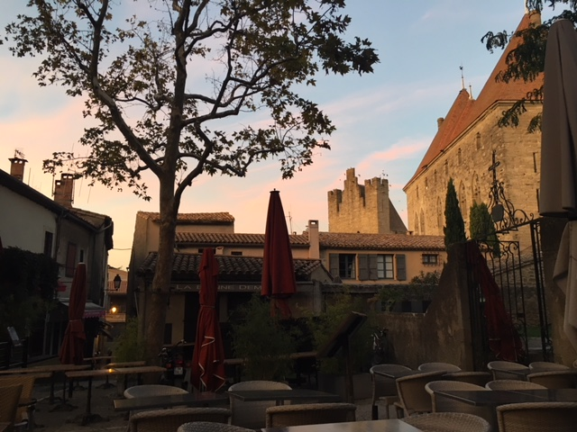
4 /10/2019 We have arrived in beautiful Carcassonne. Here is a photo of what the inside of the medevil city looks like. The area surrounding Carcassonne is picuresque. There are fields, vineyards and of course the famous Canal du Midi. Did you know that the canal was built to transport wine to the north of France? Amazing!
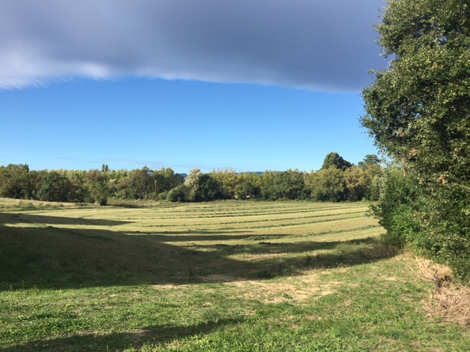
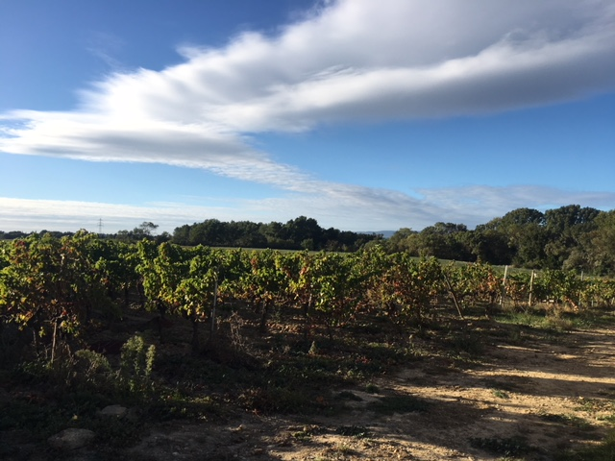
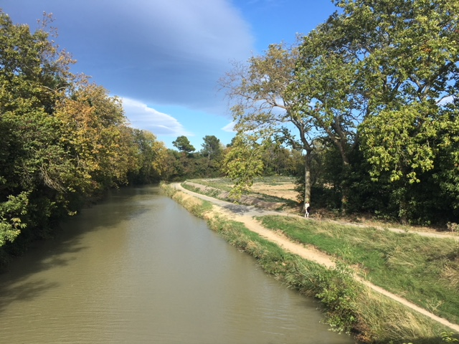

This is the Grand Puit. That means 'big well' in French. People who lived in the old city would have gotten their water from here. It must have been a really busy place.
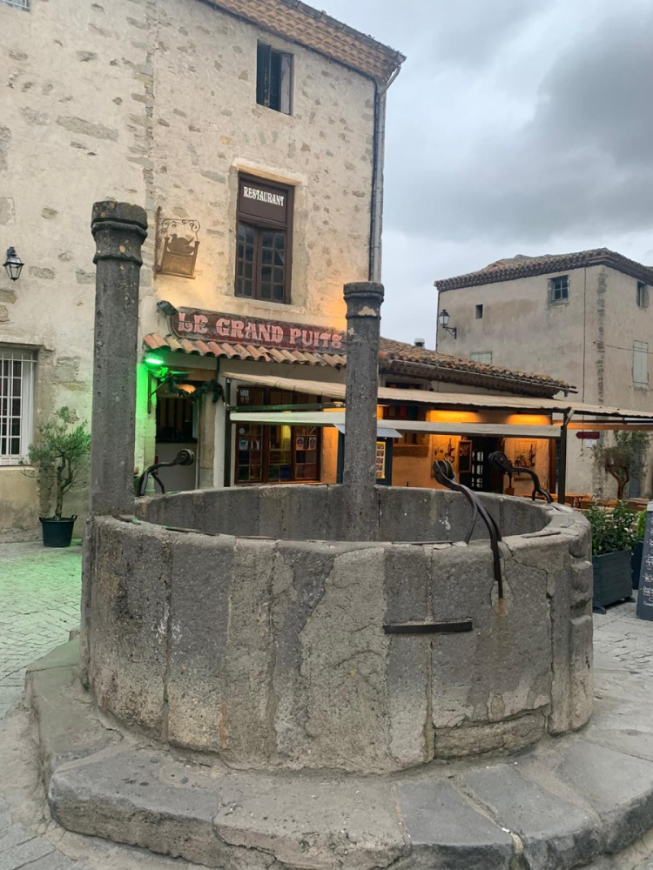
In French class we played a game of guess who. We learnt how to talk about people hair colour, eye colour and the french words for accessories such as glasses. Les Lunettes!
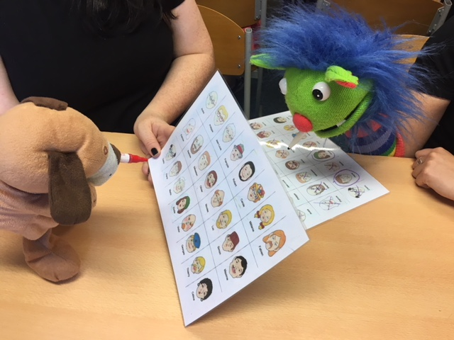

We were really lucky to be able to learn about how wine is made in France. We got to take a tour of the vineyard and to taste some French wine while we were on our training course.
