French Stall at Alma Park's Summer Fair 22 June 2019
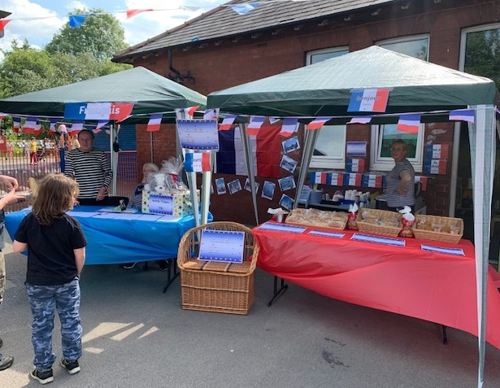
The summer fair was a great success and the French stall was a great way to promote our British Council Erasmus+ project. We sold croissants and chocolat chaud, both of which were very popular. We also held a raffle with a hamper as the grand prix! You had to choose the name of one of the French towns from a list. If your town was drawn you won the hamper. We also set up a cafe area to the left of the stalls with information about the British Counil and the Erasmus+ project and books and magazines in French. Visitors came and read about the project and we got the chance to talk about what we were doing and why. It was fun watching the children practising their French. We can't wait for next year!

